S_ALR_87099918 -

Functionality
In the cost center plan you need to include the future depreciation. For this, you can determine planned periodic depreciation for any Asset Accounting depreciation area, and transfer this to the Controlling (CO) component.
There is an indicator in the report request screen you use to specify if planning should take place on cost centers or on orders.
Scenario
The transfer program plans the depreciation, using the appropriate cost element, on the cost center or order. The report overwrites any existing panned costs for this cost element (meaning that the new costs are not added to the existing costs). When you run the report in update mode and it is not possible for the report to transfer certain values, the report terminates and issues an error message. After you correct the error, you can restart the report for the original dataset. This does not present a problem, since the plan values that were already transferred are now overwritten (rather than being added to).

Requirements
Recalculation of depreciation (AFAR) has been run.

Menu Path | Accounting → Controlling → Cost Center Accounting → Planning Aids → Transfers → S_ALR_87099918 - Depreciation/Interest FI-AA
Transaction Code | S_ALR_87099918

1. Double Click on S_ALR_87099918 - Primary Cost Planning: Depreciation/Interest

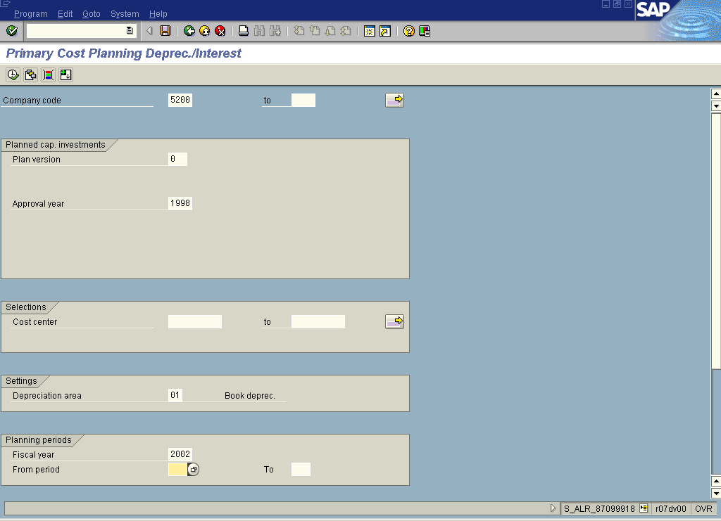
2. Update the following fields:

Field Name | Field Description | Values
Company code | The company code is an organizational unit within financial accounting. | Example: 5200
From period | From period – beginning period of transfer. | Example: 1
To period | To period – last period of transfer. | Example: 12
Fiscal year | Period, 12 months as a rule, for which the company is to create its inventory and balance sheet. | Example: 2002

3. Click More fields Button .

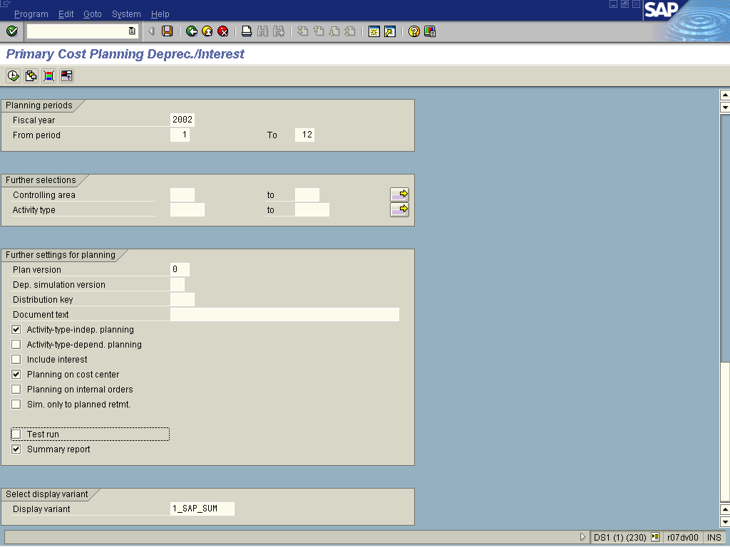
4. Deselect <checkbox> Test run .
5. Deselect <checkbox> Activity Type-dependant planning .
6. Click Execute .

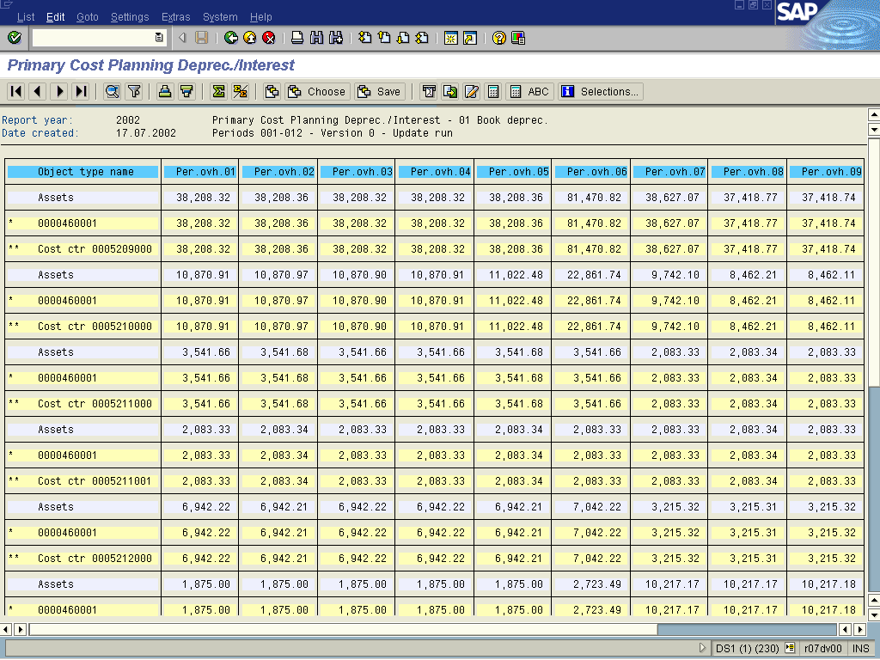

7. The system displays a list of planned depreciation by cost center.

